Al-Enhanced Career Guidance System for Personalised Career Pathways

Shreyas G Gowda
School of CSE
Presidency University
Bengaluru, India

Amoolya P N
School of CSE
Presidency University
Bengaluru, India
Soujanya Oralagi
School of CSE
Presidency University
Bengaluru, India

Mr. JaiKumar
Assistant Professor
School of Computer Science and Engineering,
Presidency University, Bengaluru, India

Abstract:

While​‍​‌‍​‍‌​‍​‌‍​‍‌ an individual is undergoing a Senior High School education, they come across various life situations that call for them to make the right educational, vocational, and social decisions. This, in turn, points to the necessity of having guidance and counselling services in schools. Its significance is beyond being emphasized. A study of this nature revealed that young people view careers more as a part of life than in terms of requirements and training. This research was conducted to find out the extent of knowledge of career counselling among senior high school students in the Agona East district and how career guidance has been a blessing to them. The qualitative approach

of a descriptive survey with the purposive sampling method was used. The information collected was elaborated based on two major themes with several sub-themes. It was revealed in the research that, for any job, different interests, abilities, personality traits, and professional values are necessary. The findings further revealed that career counselling enables students to relate what they learn to their interests, abilities, aspirations, and then come up with a suitable match for them with the existing opportunities. In the future, the research urges that educational institutions take it upon themselves to help students discover their interests and also let them know the value of academic qualifications in career ​‍​‌‍​‍‌​‍​‌‍​‍‌decision-making.

Keywords: AI, Career Guidance, Personalised Pathways, HTML, CSS, React, Python, LLM, Ollama, MySQL

I.Introduction
Career​‍​‌‍​‍‌​‍​‌‍​‍‌ guidance and counseling are instrumental in the educational and professional development of students. In senior high school, learners frequently have to make academic, vocational, and social decisions that determine their future. Getting appropriate guidance at this point in time equips them with the knowledge to relate their choices to their interests, skills, and goals.

Usually, students tend to perceive career decisions as a component of their life in general rather than concentrating on academic qualifications or training only. This, therefore, points to the necessity of well-organized career counseling programs that foster self-awareness and career exploration. Understanding their strengths, interests, and values with the help of career guidance makes students see the connection between what they learn in the classroom and the opportunities available in the real world.

This research attempts to figure out how much senior high school students in the Agona East District are aware of and understand the concept of career counselling. The researchers also looked into the benefits that students got from the programs and how the services influenced their academic and career decisions. Using a descriptive qualitative approach, the study offers valuable information on how career guidance can support youth in aligning their individual goals with becoming future opportunities, thus, they would be capable
of academic and professional ​‍​‌‍​‍‌​‍​‌‍​‍‌success.

II. RELATED WORKS:

2.1 Theoretical foundations and contemporary models of career development
Modern​‍​‌‍​‍‌​‍​‌‍​‍‌ career research highlights that the selection of a career is not a single-time decision but rather a continuous developmental process influenced by one's personality, social environment, and labour market changes.Career Construction Theory along with the Chaos Theory of Careers consider careers as processes that are self-constructed and adaptable in uncertain environments; thus, they highlight career adaptability, resilience, and proactive self-management as the main abilities that lead to career progress.According to these viewpoints, career trajectories can be either linear (ladder) or multidirectional (lattice), and the way individuals interpret, their values and adaptability guide them in navigating the possibilities and upheavals. This conceptual transition from externally-determined, hierarchical progress to internally-determined, multidimensional progress is the reason for concentrating the guidance work on adaptability and lifelong planning instead of single decision points.[1][Artificial Intelligence-Powered Personalised Career Guidance System]

2.2 Professional competencies and the role of counsellors
The​‍​‌‍​‍‌​‍​‌‍​‍‌ importance of career guidance personnel who are well-trained is a repeating theme in the literature considered the core of the most effective guidance systems. The studies suggest a clear competency profile for the counsellors which comprise strong professional ethics, being process-oriented (guidance as a continuous process), proactive outreach, having knowledge from various fields (psychology, labour market, pedagogy, basic IT), being skilled in assessment and information-processing as well as having good communication/consultation skills. In order to enhance these skills, the literature proposes higher standards for the entry qualifications, planned continuing education and training at work, and the provision of benefits to research and practice integration—steps aimed at creating a profession and at the same time ensuring the quality of the service is at a certain level. The point made is that the competence of the counsellor has a direct effect on the

accuracy of performing the assessments, the getting of the correct recommendations and the ability of the support staff to recognise different students’ needs. [2][ Research on the Construction of Core Professional Literacy System and Professional Improvement Path for Career Guidance ​‍​‌‍​‍‌​‍​‌‍​‍‌Personnel]

2.3 Students’ experiences, influences and decision-making difficulties
Theoretical​‍​‌‍​‍‌​‍​‌‍​‍‌ research investigating the lived experiences of students shows a number of consistent themes: (1) students usually understand careers as part of their life goals and identity rather than just as qualifications; (2) in most cases, the personal interests of the students are the deciding factor and the advice of a counsellor or parent only has a minor influence when students make subject and career choices; and (3) a lot of students have problems in making decisions—especially those who have higher neuroticism or lower extraversion—that show as lack of information, lack of readiness, or inconsistent preferences. Qualitative research in senior high schools has revealed that students understand better the types of careers and the fit between a person and the environment when career information is provided systematically (through lessons, interviews and counsellor outreach). Nevertheless, the extent, the depth and the counsellor contact differ a lot from school to school, thus the results are not the same in all the schools. The results emphasize the necessity of not only universal career education but also of targeted counselling for the vulnerable or the undecided students.[3] [ Career Guidance and Its Implications for Students’ Career Choices: The Case of Public Senior High Schools in ​‍​‌‍​‍‌​‍​‌‍​‍‌Ghana]
2.4 Technology-enhanced and AI-driven career guidance systems
Recent applied research explores how digital tools—particularly machine learning (ML) and artificial intelligence (AI)—can scale and personalise career guidance. Several prototypes and pilot systems use classification/regression models (e.g., Random Forests), recommendation engines, case-based reasoning and hybrid AI pipelines to process academic records, psychometric inputs, labour-market indicators and
user preferences in order to suggest suitable subjects or careers. Advantages reported include scalability, the ability to incorporate labour market trends, and continuous learning from user interactions. Studies also caution that many early systems over-relied on academic scores (thereby missing non-cognitive traits), or lacked sufficient personalization, evaluation against real-world outcomes, and integration with human counsellors. Rigorous user testing, transparency of recommendation logic, and mechanisms for continuous feedback are repeatedly recommended. [4][ Developing a Smart Career Guidance System for Rwandan Education]

2.5 Psychometric and personalised approaches: integrating values, emotions and behaviour

A strand of recent work integrates psychometric profiling with AI to deepen personalization. Systems that combine established trait/interest frameworks (e.g., RIASEC) with richer psychometric dimensions (emotional values, motivational constructs) can generate recommendations that align not only with competence but also with values and likely satisfaction. Implementations that include features such as test-history tracking, match-percentage reporting, and interpretability modules help users reflect on changes in preferences over time and build longitudinal self-awareness. These psychometric + AI platforms show promise in producing more meaningful matches and improving user acceptance—provided they respect privacy, maintain transparency about model limitations, and supplement algorithmic suggestions with human counselling. [5][ AI-Powered Psychometric Based Career Counseling: A Novel Approach to Personalized Career Guidance]

2.6 Implementation methods, evaluation practices and common limitations
Across the technology literature, common methodological choices include mixed-methods evaluation (surveys + user testing), supervised ML models trained on historical academic/performance data, and rule-based modules encoding career requirements. Evaluation often reports system accuracy, user satisfaction, and cross-browser/functional testing. However, several limitations recur: datasets are frequently small and localized; models can overfit to academic indicators while underrepresenting soft skills and aspirations; many studies lack longitudinal follow-up to check real-world career outcomes; and ethical issues (bias, fairness, data privacy) receive limited empirical treatment. Authors therefore recommend multi-stakeholder testing (students, counsellors, employers), iterative user-centred design, and explicit strategies to mitigate algorithmic bias. [5][ AI-Powered Psychometric Based Career Counselling: A Novel Approach to Personalized Career Guidance]

2.7 Research gaps and implications for the Agona East senior high school context
Identified​‍​‌‍​‍‌​‍​‌‍​‍‌ through the literature review are important holes in knowledge that are highly relevant to the study of senior high school students in Agona East you are conducting. Initially, while numerous AI-driven instruments base their focus on tertiary education or datasets of a whole country, scarcely are they tested for their efficiency in school-level contexts that lack resources and where the capacity of counsellors and availability of data are uneven. Secondly, psychometric and personality factors (which have a major influence on decision difficulties) are very scarcely mentioned in most practical guidance interventions; thus, if schools integrate these factors in their programmes, the students will experience less indecision and will be better aligned. Thirdly, the continuous training and professionalization of school counsellors is, as per numerous sources, the most crucial aspect that is, however, very hardly implemented—hence, local capacity building and the provision of simple, school-friendly tools may be extremely effective interventions. Lastly, the number of studies that use qualitative methods to gain insights into the students' lived experiences of careers, and at the same time, use quantitative predictive models is very limited; hence, the use of mixed-methods designs that give priority to the student voice and at the same time provide decision support is highly ​‍​‌‍​‍‌​‍​‌‍​‍‌advised.

III.TAXONOMY OF Al-ENHANCED CAREER GUIDENCE SYSTEM FOR PERSONALIZED CAREER PATHWAYS.
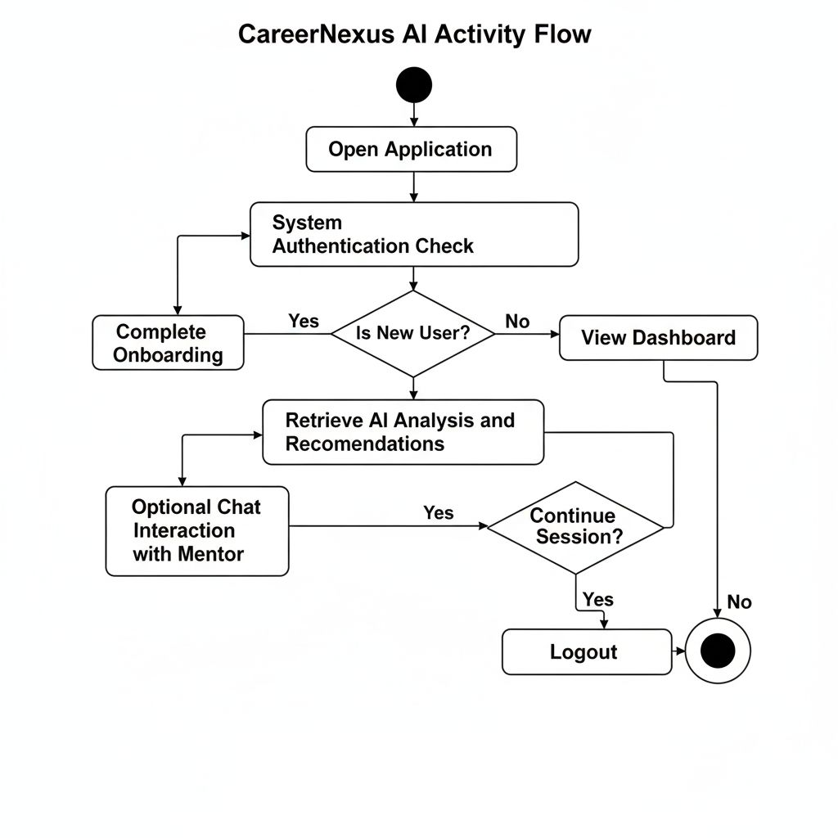
Fig 3.1 System design
3.1​‍​‌‍​‍‌​‍​‌‍​‍‌ Entry & Authentication (Start → Auth check)

App launching by the user means first of all authentication check. The system verifies whether there is a session token, a login cookie, or credentials stored. In case the token is present and valid, the user is given the status of authentication and goes on without any obstacles. Otherwise, the system is to figure out whether to ask for login credentials, indicate a guest state, or get onboarding started for a new account. Some of the important sub-steps and safeguards are:
Confirm that a token is legitimate by checking the expiration date, the signature, and the revocation list.
Fallbacks: a user is asked for a log-in again if re-validation fails; also there could be an offline mode with locally stored data in a case of a missing network connection, however, this mode should be safe.
Logging & metrics: keep track of auth attempts for security and analytics (at the same time, do not store any PII data).

3.2 Decision Branch: New User → Onboarding | Existing User → Dashboard
The point to decide in the chart is just this. The system either checks a flag like has_onboarded or looks at the profile completion:
If a user is new / has not been onboarded: An onboarding flow will be prompted — a visually guided and interactive way to collect user profile data (name, educational background, skills, wants, preferred learning method), execute initial aptitude/assessment tasks, and build the base profile in the database. Profile building should incorporate various validations (e.g., mandatory fields), UX elements (progress bar), and an option of skipping with a reminder for later.

If a user is already there / has been onboarded: Immediately load the personalized dashboard. The dashboard gets the data from the saved profile, the latest AI processing, and the stored UI state.
Remarks on the decision logic: treating the onboarding process as idempotent is possible — doing it again will not corrupt data. Further, you may also consider an "incomplete onboarding" status that lets users continue from where they stopped.

3.3 AI Analysis Retrieval & Other Dashboard Work

On arriving at the dashboard, the user triggers a demand to the system for or a computation of the AI-powered career analysis. The normal procedure is:Get profile data from the DB.
Attempt to find the latest AI output for the respective request to check if the work done could be reused if the cached copy is also fresh. In this case, the cached version is used.
If the cached one is old or there is none, the local LLM pipeline (Ollama + custom model) is called to produce fresh analysis: aptitude summary, skill gaps, recommended career tracks, learning resources, and timeline.
The Neural Pathway Dashboard takes the data (or cache) saved in the database and displays it.
While neural processing is going on, in addition to a loading state, partial pieces of information can be presented as a way of demonstrating progress to the user (e.g., quick tips).

3.4 Optional Chat Interaction (Neural Mentor)
The user may from the dashboard communicate with the Neural Mentor — a chatbot that understands context. Some of the design considerations are:

Context memory: To be relevant, the bot should get access to both the user profile and the recent chat history.
Session scope: For each chatbot message, LLM is invoked with a system prompt + user context; proper prompt engineering should be used so that no sensitive data are leaked.
Non-blocking UX: the presence of typing indicators and conversation history may be shown; if the user agrees, meaningful Q&A can be saved to the profile.
Actionable output: Provide clear next steps to the user, e.g. (Enroll in a course, complete a micro-task, get resume tips) and let the user decide whether to accept or dismiss the ​‍​‌‍​‍‌​‍​‌‍​‍‌suggestions.3.3 Database: In terms of the database, it uses either MySQL to safely store user information, educational resources, progress reports, and feedback.

3.5​‍​‌‍​‍‌​‍​‌‍​‍‌ Active Loop & Interaction Flow Until Logout

The app keeps running in a loop allowing the user to: check out different career tracks, retake assessments, request follow-up analyses, get advice from the mentor, or change their profile. Main features:
State persistence: any user input has to be kept and shown right away both in the dashboard and AI environment.
Recomputation triggers: the AI should be signalled to redo recommendations if one edits their skills or takes an assessment.
Concurrency & rate-limiting: do not let the local LLM be hit by too many requests at once; frequent calls should be queued or debounced.
Autosave & recovery: in case of app or browser failure, the user should be able to continue (transactional writes are helpful here).

3.6 Logout / End (Exit condition)
The user terminates the loop by logging out explicitly or when the session expires. Some implementation details are:
Clean session teardown: along with token revoking and clearing temporary caches, sensitive data in local storage can be cleared as well.
Security: make sure that logout invalidates server/session state so that the attackers cannot replay the session.
Analytics: in order to enhance the product, log the session duration, last activity time, and important user actions (while being respectful to privacy).

3.7 Error Handling, Edge Cases & Non-functional Concerns

Network failures: in such cases, the app should have an offline fallback and show error messages that explain the situation; it should also queue the actions to be retried later.

AI failures: when the LLM cannot be reached, besides showing cached results, the explanation should also be given; the users should be allowed to manually choose an advisor or the system should simply use a rule-based fallback.
Partial onboarding: users should be able to save their progress and come back later to finish.
Permission & privacy: do not forget that consent should always be given before saving or reusing any sensitive data.
Performance: AI outputs should be cached, assessments divided into pages, and UI components should be gradually loaded.

3.8 Simple Activity Diagram Text (UML-style steps)

Start → Open App → Auth Check → [Authenticated?] → If No → Show Login/Onboarding → Complete Onboarding → Create Profile → AI Analysis → Dashboard → Optional Chat → User Actions Loop → [Logout?] → If Yes → Teardown Session → ​‍​‌‍​‍‌​‍​‌‍​‍‌End.

IV. PROJECT OUTCOME
CareerNexus​‍​‌‍​‍‌​‍​‌‍​‍‌ AI is a full, privacy-centric career guidance product that employs local AI to comprehend the user's strengths, goals, and abilities and then drafts a personalized roadmap for the future. Based on the analysis of aptitude, interests, learning style, and current skill levels, the system positions users in a certain way and tells them what skills they still lack. It features a modern, glassmorphic UI combined with a powerful backend driven by Flask, MySQL, and a custom Llama 3 model on Ollama to make sure that all data are kept secure on the user's device.

The platform creates a detailed career pathway dashboard and also has an intelligent mentor that can recall previous conversations to provide more accurate, long-term guidance. In essence, the initiative is a successful intermediary between a user's current capabilities and the career of their dreams, thus a clever, personalized, and reliable substitute for the conventional counseling ​‍​‌‍​‍‌​‍​‌‍​‍‌method.

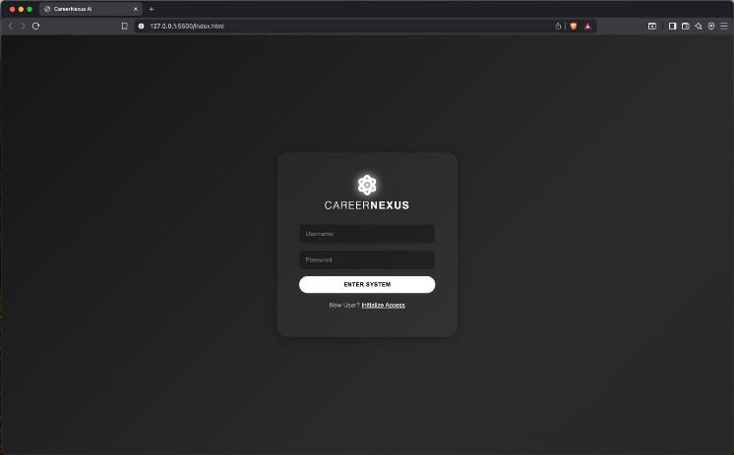

Fig 4.1

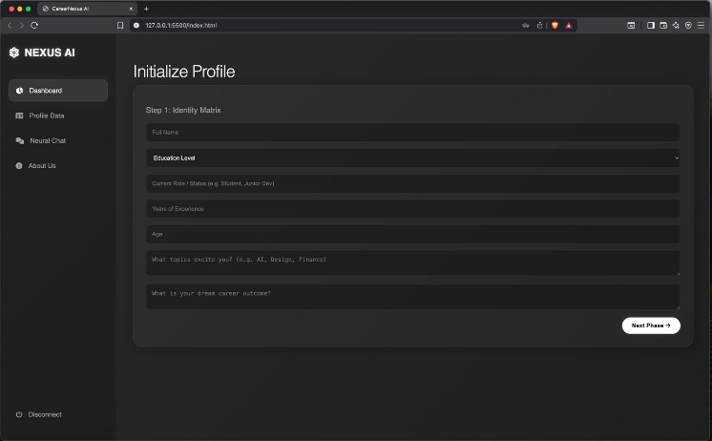

Fig 4.2
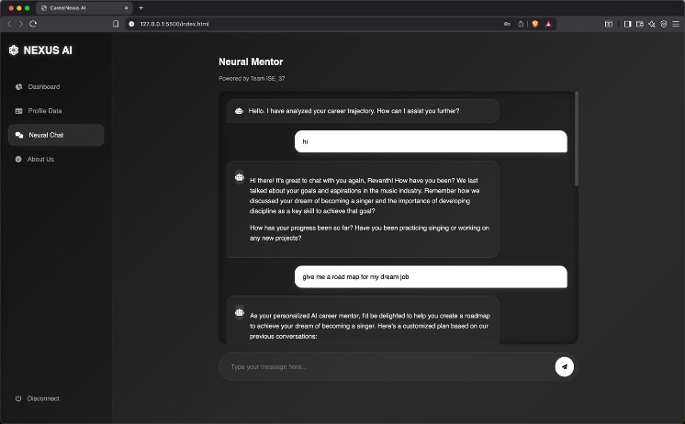
Fig 4.3

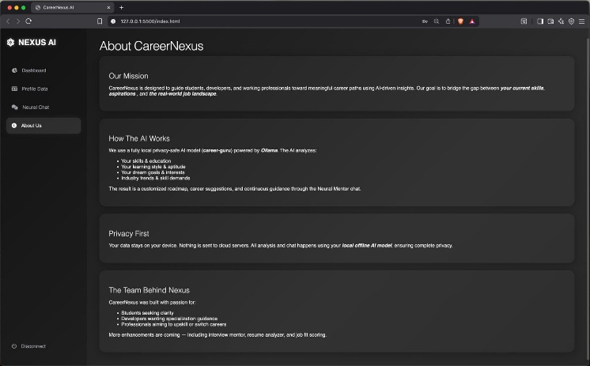
Fig 4.4
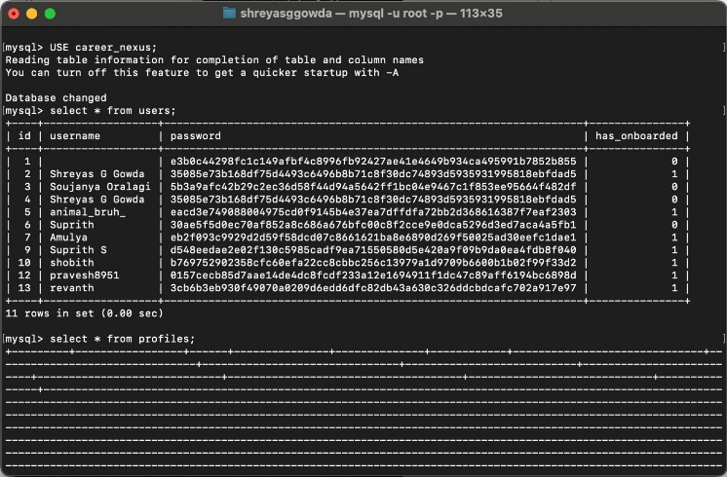
Fig 4.5

V .Conclusion
CareerNexus​‍​‌‍​‍‌​‍​‌‍​‍‌ AI is a perfect example of how smart systems can radically change the way people do career planning by delivering personalized, data-driven, and truly helpful guidance. The initiative efficiently mixes aptitude testing, cognitive profiling, and skill-gap identification to present users a detailed understanding of their personality and the suitable ways for them.
Through the use of a locally hosted LLM via Ollama, the platform maintains privacy and earns trust while providing top-notch AI insights. The trendy glassmorphism UI along with the efficient backend work through Flask and MySQL makes the user journey smooth, and it is a great way to get users to know their strengths and the futures they can build with certainty.
In the end, this initiative is a testament to the fact that AI can be a powerful and giving tool if used with the right intention and in the right way, thereby, students and professionals gain in terms of clarity, direction, and a feasible route to their long-term objectives. It is placing CareerNexus AI not only as a means, but a reliable digital mentor that changes with the user and supports him/her in getting to the next level in career ​‍​‌‍​‍‌​‍​‌‍​‍‌growth.

VI.REFERENCES
- Kulugh, V.E., et al. “Artificial Intelligence-Powered Personalised Career Guidance System.” March 2025
- “Research on the Construction of Core Professional Literacy System and Professional Improvement Path for Career Guidance Personnel”, School of Computer Science and Communication Engineering, Jiangsu University, Zhenjiang, China, July 5, 2025
- JoshuaLutherNdoyeUpoalkpajor1*“Career Guidance and Its Implications for Students’ Career Choices: The Case of Public Senior High Schools in Ghana”, 04 September 2020
- Gabriel Nishimwe1, Dr Wilson MUSONI2, “Developing a Smart Career Guidance System for Rwandan Education” , 8, August – 2024
- Kamlesh Patil1, Dr Nilofar Mulla2, Radhika Dhangare3, Gayatri Mahabudhe4, Prayuja Patil5, Pooja Gangane6, “AI-Powered Psychometric Based Career Counselling: A Novel Approach to Personalized Career Guidance”, 07 July 2025
- Westman, S. “Artificial Intelligence for Career Guidance.” IAFOR Journal of Education: Technology in Education, Vol. 9, Issue 4, 2021.
- Wang, D., et al. “A Systematic Review on Career Interventions for High School Students.” PLoS ONE / PMC, 2024.
- Widiasari, S., Indreswari, H., Setyowati, A.J., Bariyyah, K. “Students and School Counselors Needs Analysis on the Development of Career Planning Guidance in Senior High School.” Proceedings of ICSES 2023, 2023.
- Bahalkar, P., Peddi, P., Jain, S. “AI-Driven Career Guidance System: A Predictive Model for Student Subject Recommendations Based on Academic Performance and Aspirations.” IJMI / Health Informatics Journal, 21 Nov 2024.
- “ Career counselling and its knowledge among high school students.” International Journal of Community Medicine and Public Health, 2017.
- Kavutha J., Kimani M., Maithya P. “Influence of Career Guidance and Counselling Service on Academic Performance of Secondary School Students.” IOSR Journal of Research & Method in Education, Vol.14, Issue 3, July 2024.
- Shabangu, S. “An Exploration of Growth Strategies for a Career Guidance Counselling and Assessment Programme for Disadvantaged High Schools (Eastern Cape, South Africa).” Doctoral Dissertation, 2025.
- Pimple, A. “Career Compass: An AI-Powered Career Guidance System Based on Interests, Skills and Soft-skill Profiling.” TechRxiv, preprint.
- Lokam, G.V., Patil, P.S., Kukade, A.S., Dhule, A.N., Kothiwale, R.A. “AI-Based Career Guidance System.” International Journal of Creative Research Thoughts (IJCRT), Vol.13, Issue 5, May 2025.
- Han, Y. “A Career Guidance and Career Planning Assessment Method Based on Improved Correlation Analysis.” 2022.
- Upoalkpajor, J.-L.N. “Career Guidance and Its Implications for Students’ Career Choices: The Case of Public Senior High Schools in Ghana.” September 2020.
- Akbar, H., Ahmad, S., Muhammad, H. “College Students’ Struggles with Career Decisions and Their Personality.” August 2023.
- Nishimwe, G., Musoni, W. “Developing a Smart Career Guidance System for Rwandan Education.” August 2024.
- Cheng, Y. “The Development of Artificial Intelligence in Career Guidance Education.” European Journal of Artificial Intelligence & Machine Learning, Vol.2, Issue 4, October 2023.
- Patil, K., et al. “AI-Powered Psychometric Based Career Counseling: A Novel Approach to Personalized Career Guidance.” July 2025.
- Bankins, S. “Navigating Career Stages in the Age of Artificial Intelligence.” 2024.
- Eze, P., Lunn, S., Berhane, B. “Evaluating LLMs for Career Guidance: Comparative Analysis of Computing Competency Recommendations Across Ten African Countries.” October 2025.
- Faruque, S.H., Akter, S., Akter, S. “Unlocking Futures: A Natural Language Driven Career Prediction System for Computer Science and Software Engineering Students.” May 2024.
- Mullens, D., Shen, S. “2ACT: AI-Accentuated Career Transitions via Skill Bridges.” May 2025.

